

**SCHOOL OF COMPUTER SCIENCE AND ENGINEERING**

**"Streamlining Email Management: Enhancing Efficiency and Organization"**

**Submitted to Lovely Professional University**

**“DEGREE OF BACHELOR OF TECHNOLOGY [COMPUTER SCIENCE AND ENGINEERING]”**

**Submitted By:**

**Name Registration No.**

|  |  |
| --- | --- |
| **Barnwal Jyoti Kumari** | **12221683** |

### DECLARATION

#### I hereby declare that the project work entitled **"Streamlining Email Management: Enhancing Efficiency and Organization**" is an authentic record of our own work carried out in B. Tech degree in Computer Science and Engineering from Lovely Professional University, **Phagwara**.

All the information furnished in this project report is based on my own intensive work and is genuine.

**Name of Studen Registration NO-**

I

Barnwal Jyoti Kumari 12221683

**ACKNOWLEDGEMENT**

This project wouldn't have been possible without the support and guidance of several individuals and resources, whom I would like to express my gratitude towards. I extend my sincere appreciation to sir Shruti mam for their invaluable guidance and encouragement throughout the project. Their expertise and insights have been instrumental in shaping the direction of this automation endeavor. I am also grateful to the Automation Anywhere community for their wealth of knowledge, resources, and forums that have provided assistance and solutions during the development of this project. Furthermore, I would like to thank my colleagues and team members for their collaboration and support during the implementation phase. Their contributions have been indispensable in overcoming challenges and achieving project milestones. Lastly, I am thankful to my family and friends for their unwavering support and understanding during the course of this project. Their collective efforts and encouragement have been instrumental in the successful completion of this automation project.

**Introduction**

Effective communication is essential for successful organizational operations in today's digital environment. Email is still the most widely used form of communication in modern businesses since it is reliable, instantaneous, and universal. However, the underlying management systems that oversee the creation, distribution, and upkeep of email accounts have a major impact on how effectiveemail communication is. Data integrity can be jeopardized and corporate operations can be disrupted by inefficient systems that cause delays, misunderstandings, and security concerns.

Strong solutions that simplify email administration are desperately needed, especially considering the vital role that email plays in business communications. In order to serve the changing needs of contemporary companies, these systems must not only make it simple to set up and maintain email accounts, but also guarantee that these accounts are safe and well-organized.

The Email management system was created utilizing an organized, object-oriented methodology in order to meet these criteria. This system contains all the features required for complete email account administration, and it is based around a Java class called Email. It offers tools for controlling mailbox capacities, automatically creating secure passwords, and allocating email addresses based on employee names and departments. The solution makes it easier for the company to efficiently manage its communications infrastructure by combining these functions into a single class.

Effective email management systems are essential for maintaining smooth communication channels, enforcing security procedures, and facilitating adherence to data protection laws. They are not merely for creating and managing email accounts. Such systems must not only manage enormous volumes of data but also protect sensitive information from unwanted access and potential breaches in light of the growing cybersecurity risks and strict privacy rules.

Email is a vital tool for day-to-day operations in the dynamic world of corporate communication, allowing for instantaneous and traceable exchanges across international networks. The administration of email systems becomes in importance as firms grow and the amount of electronic correspondence rises, as it has a direct impact on organizational effectiveness and productivity.

Moreover, the significance of this kind of system has increased due to the growing size and reach of business settings, where email is no longer only a vital tool for communication but also plays a vital role in marketing, customer service, and workflow management. As a result, the email management system is made to increase overall communication efficiency and enhance the logistical aspects of email management, guaranteeing that each email account is a vital, trustworthy, and secure.

**System Overview:**

The Email class, a Java-based component that encompasses numerous operations involved with managing email accounts within an organizational context, serves as the foundation for the email management system. The creation and management of email accounts, password management, and mailbox settings—all essential for the efficient running of any organization's communication network—can be automated and made simpler with this system.

Components of the Email Class:

Individual Member Variables: Several private variables in the class hold important data, including:

firstName, lastName: The user's first and last names are stored in these variables and are utilized when creating the email address.

Password: The email account's securely created password is stored in this variable.

Department: This keeps track of the email address's departmental identification, which is used to group emails together according to department.

Email: This variable, which is created using the user's name and department, contains the entire email address.

MailboxCapacity: An integer with a default value of 500 MB that indicates the email account's storage capacity.

AlternateEmail: A backup email address that can be stored optionally.

Company Suffix: A string that stands for the domain that all email addresses inside the company utilize.

3. Implementation Details:

Class Design:

Attributes:

firstName, lastName: Store user's name.

password: Securely stores the user’s password.

department: Indicates the user's department.

email: Formulated as firstName.lastName@department.companySuffix.

mailboxCapacity: Defaults to 500 MB but can be adjusted.

alternateemail: Optional secondary email address.

companySuffix: A predefined email domain (lpuemail.com).

Advantages:

Enhanced Security: The system guarantees strong security for email management by automating the creation of passwords and limiting access through encapsulation.

Enhanced Efficiency: Saves time and minimizes errors by streamlining the creation and management of email accounts.

Scalability: The capacity to easily modify the underlying code to accommodate expanding organizational needs.

Problems and Their Fixes:

User Input Error Handling: To handle erroneous or invalid user inputs gracefully, strong error handling systems were put in Integration with Current Systems: The system's adaptable architecture makes it simple to integrate with current IT systems.

**Code:**

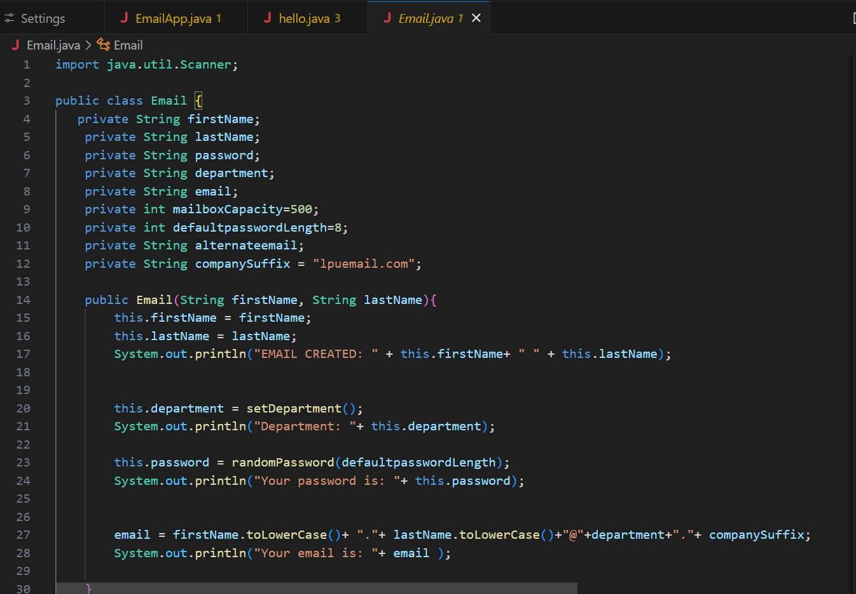

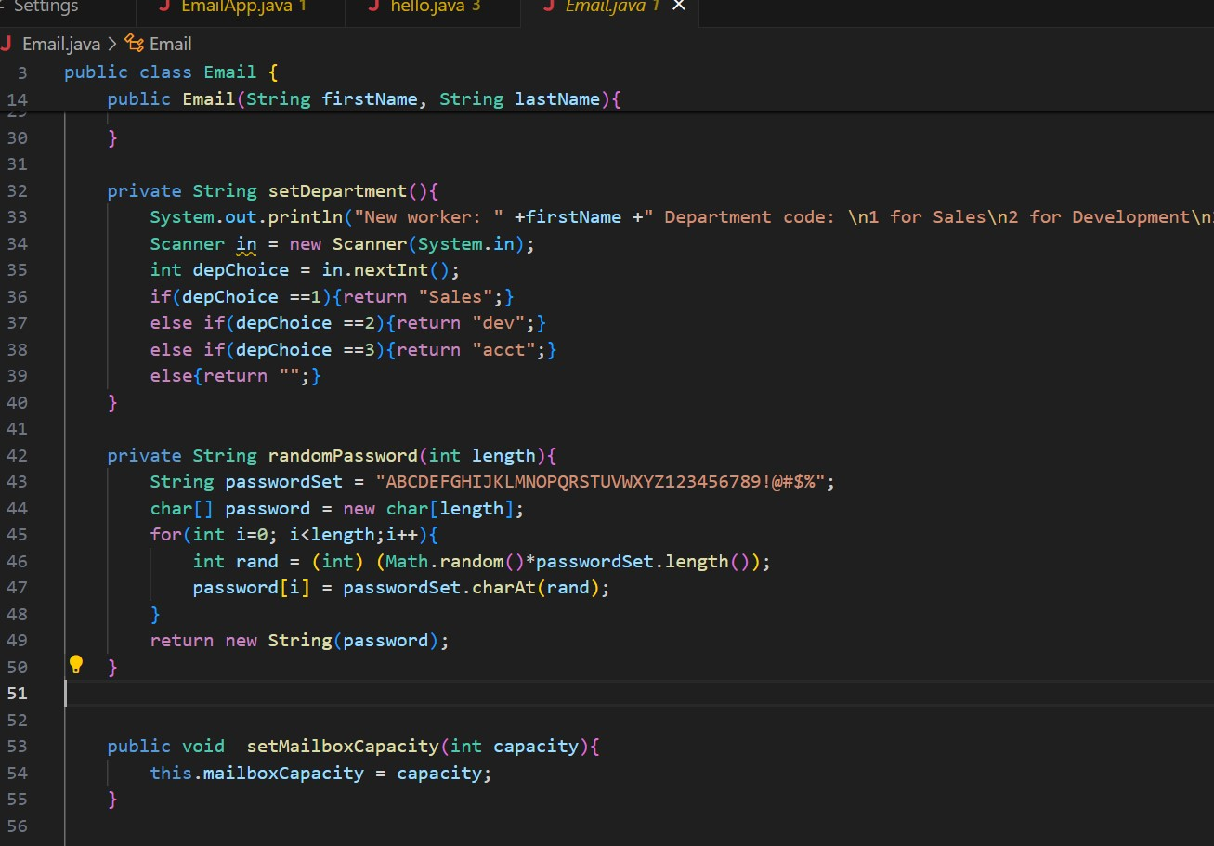

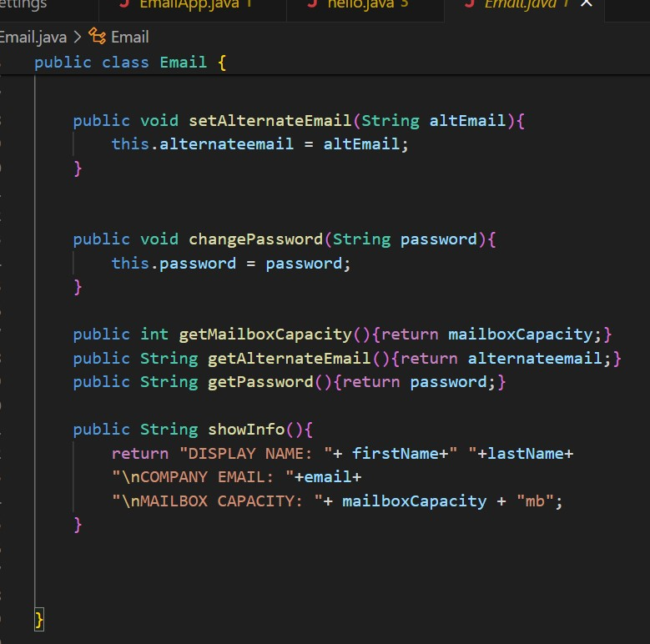

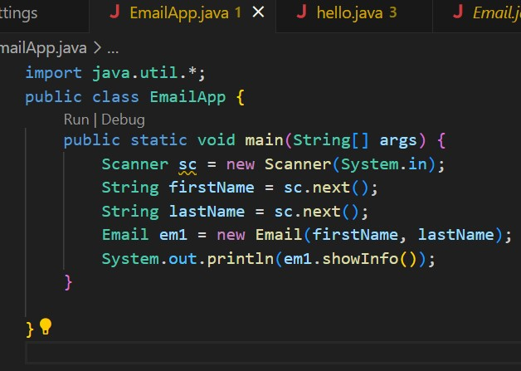

**Output:**

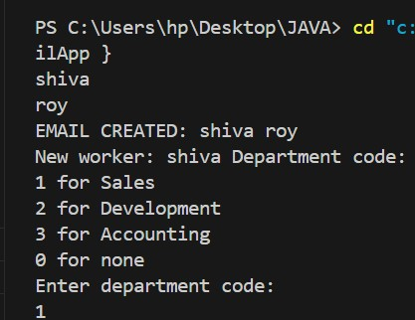

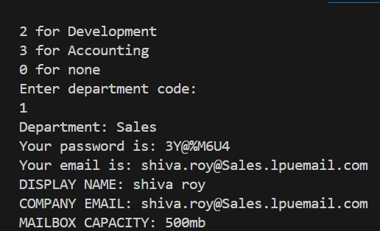

**Conclusion:**

The Email management system is a major advancement in organizational communication technologies. It provides an effective, safe, and user-friendly email management solution by combining essential features into a single, manageable class.